Juvenile Crime – Crime committed by children
Fact:
A higher percentage of juveniles are arrested than adults
Juvenile Crime in Australia is quite common. So common that in fact about 80% of Australians have been spoken to by the police, given a caution, or arrested during their childhood.

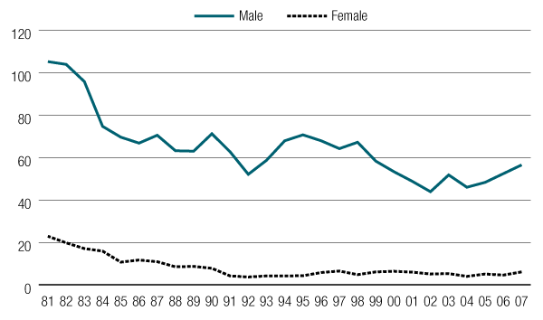
Persons in juvenile detention centres, from 1981 to 2007, by sexª(per 100,000 of that sex per year)

Juvenile Detention Centers
Juvenile detention centers are a place where young offenders are safe and secure, either carrying out their sentence, or waiting to appear in court. In Western Australia there is one juvenile detention center – Banksia Hill Detention Centre. Residents of the centers have access to education, recreation, training, and counseling according to their individual “case plan”.

Juvenile Court Cases
Most juvenile cases are dealt with by the Juvenile (Or Children’s) court. The outcome and punishment of the case is decided by a specialised children’s judge or magistrate acting under jurisdiction.

Juvenile Justice System
Created By Nicholas Ireland, 2011 Murdoch College Australia
For a more detailed chart, visit: http://www.voc.sa.gov.au/images/juvenile_chart.jpg

Family conference: The family of the offender is consulted to see if they can deal with the offender themselves.
Obligation: Such as an apology
Community Service
Punishments if guilty
Payment or compensation to the affected person or family
Detention: Similar to jail, only aided to help young people return to society
Not guilty: No further action is taken
Arrest: The offenders are taken by the police to face court under criminal charges
Caution: The offenders are given an official warning, as such that they will be arrested if they re-offend
Police use discretionary powers to decide whether to arrest, caution, or have a family conference
Juveniles commit the crime, Police catch the offender.

